COASTAL Physical Therapy Group, LLC.

Patient Intake Form

Patient Information:
Last Name: First Name: Sex:
Date of Birth:
SS#

Injury: Work or Auto related (Y/N) Allergies or Medical Precautions:
Emergency Contact: Phone#: (
) -
Address: City: State:
Zip Code: Work#: (
) - Home#: (
) -
Email:
Mobile#: (
) -
Marital Status: Single Married Divorced Widowed Domestic Partner

Employer’s Name: Occupation:

Insurance Information:

Insured’s Name: SS#: Date of Birth:

Insured’s Employer’s Name:

Insurance Co. Name: Policy#:

Secondary Insurance Information: (if applicable)

Insured’s Name: SS# Date of Birth:

Insurance Co. Name: Policy#:

COASTAL Physical Therapy Group

Patient History/Questionnaire

Name:
Date of Birth:
Right or Left-handed
What is your Primary Complaint?

Have you had surgery for this condition?_________ What surgery?_______________ When? ______________

Where is your problem? Indicate on the body chart below using symbols. Pain xxx: Numbness ooo: Tingling zzz:

Indicate the nature of your pain and symptoms: Sharp
Dull
Piercing Shooting
Aching
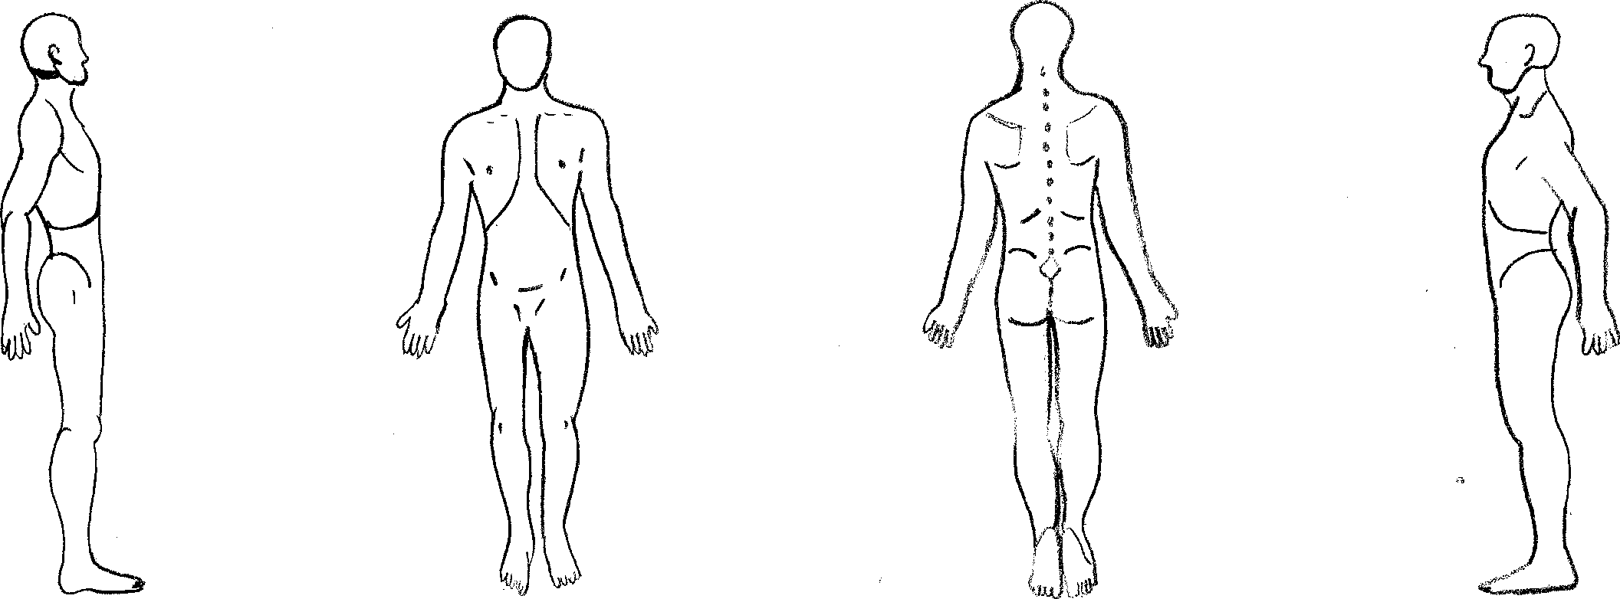
Ac

When and how did this problem begin?

What makes your symptoms/ pain worse?

What makes your symptoms/ pain lessen?

Rate your pain on a visual scale (0-10) 0 = no pain, 10 = excruciating pain:

Are your symptoms worse in the: Morning Afternoon Evening Inconsistent

Are your Symptoms: Improving Worse Stable

Are your

COASTAL Physical Therapy Group Medical History

Has this problem affected your daily life or routine? Briefly describe in what ways.

Have you had similar episodes of this current problem in the past? __________
Have you undergone any special tests for this condition? (X-rays, MRI’s, etc) If yes, do you know the results?
___________________________________________________________________________________________

Please answer the following questions: Yes No

1) Do the current problems interrupt your sleep?
2) Do your symptoms change with coughing or sneezing?
3) Have you had any recent changes in bowel or bladder function?
4) Do you have a history of neck or back problems?
5) Do you experience any dizziness or vertigo?
6) Have you had any recent unexplained change in your weight?
7) Do you take blood thinners?
8) Are you pregnant?
9) Do you have any allergies?
10) Have you noticed any shortness of breath or decrease in exercise tolerance?
11) Do you use any assistive device? (cane, foot orthotics)
12) Do you have high blood pressure?
13) Do you have any cardiac problems?
14) Do you have diabetes?
15) Have you ever had cancer of any sort? Type? When?
16) Do you have osteoporosis?
17) Do you have a pacemaker/defibrillator/stimulator of any type?
Any other illness, past injuries, past surgeries we should be aware of? List the medications you are currently taking over the counter and prescription: (Attach a list if necessary):

COASTAL Physical Therapy Group, LLC

Billing Policy, Release, and Authorization

I authorize COASTAL Physical Therapy Group, LLC to bill my insurance company directly for the covered portion of charges, and I authorize payment of benefits directly to Coastal Physical Therapy Group, LLC. I authorize Coastal Physical Therapy Group, LLC to release medical or other information necessary to process this claim. I understand that I am ultimately responsible for my physical therapy charges, and I agree to pay my deductible, my co-insurance or co-payment, and any charges not reimbursed by my insurance carrier. I understand that some insurance companies require medical or administrative pre-authorization for treatment or have reimbursement limits on physical therapy treatments. I understand I am responsible for knowing and meeting the requirements of my insurance plan.

Signature: Date:

COASTAL Physical Therapy Group, LLC
9657 B Ocean Hwy, Suite 3
Pawleys Island, SC 29585
Phone (843) 585-3303 Fax (843) 874-3174

WRITTEN ACNOWLEDGEMENT OF RECEIPT OF NOTICE OF PRIVACY PRACTICE

I hereby grant consent for treatment or services to be provided by COASTAL Physical Therapy Group, and their trained therapists and health care staff.
Disclosure of protected health information (PHI): I understand that my personal health information is protected by federal regulations under either the health information, portability and accountability act (HIPPA) or the family, educational rights and privacy act of 1974 (FERPA) and may not be disclosed without either my authorization or consent. I also understand that I am not required to sign this authorization/consent in order to be eligible for participation in treatment.
I hereby consent to and authorize, COASTAL Physical Therapy Group’s physical therapists and healthcare personnel to disclose protected health information and any related information regarding an injury or illness during my treatment plan of care to referring physicians, primary care physicians, and insurance companies as required for payment.

I, (Patient-PRINTED NAME):

hereby acknowledge that I have received a copy of “The Notice of Privacy Practices”.

Signature:

Relationship to Patient (if patient is a minor):

Date:

COASTAL Physical Therapy Group, LLC

Cancellation/No Show Policy

Dear Valued Patient:

The staff of COASTAL Physical Therapy Group is committed to providing the highest quality of care possible with today’s ever-changing economy. As a result, should you have to cancel an appointment, we request you contact us at least 24 hours in advance of your appointment. If you cancel with less than 24-hour notice or are a “No Show” you will be subject to a $45.00 cancellation fee. We will allow you 1 “free pass” without charging you.

If you need to reschedule an appointment, we request you reschedule to a day within the same work week at no charge.
Your cooperation is greatly appreciated.
Thank you,

COASTAL Physical Therapy Group

I have read and agree to the above terms and conditions.
Print Your Name

Your Signature Date Signed

